3A - Measurement – Lesson 01
Units and Applications – Managing Errors.

Name: _________________

- When we measure anything there is always some ______ in the measurement.

- What should we do to make sure that our measurement is as accurate as possible?

- Measure your desk three times with a ruler in centimetres. [We don’t expect the same answer each time due to the limitations of the ruler.]

Length 1 = Breadth 1 =  Length 2 = Breadth 2 =  Length 3 = Breadth 3 = | Average Length = ( __ + __ + __ ) ÷ 3  = ___ cm = ___ m  Average Breadth = ( __ + __ + __ ) ÷ 3  = ___ cm = ___ m

Desk Surface area = Average Length x Average Breadth

= ___ x ___ = ___ m²

- Go to a chemist and ask them to measure your blood pressure three times. Ignore the most extreme values.

Systolic 1 = Diastolic 1 =  Systolic 2 = Diastolic 2 =  Systolic 3 = Diastolic 3 = | Average Systolic = ( __ + __ ) ÷ 2  = ___ mm  Average Diastolic = ( __ + __ ) ÷ 2  = ___ mm

- What is the smallest unit would you use the distance from here to Sydney.

(A) millimetres (B) metres (C) kilometres (D) 10 kilometres

- The error is half of the amount in question 5). That is ______ .
- A wooden plank is measured as 345cm to the nearest cm,

  - What is the error? ___ (Half the smallest unit)


  - Upper limit = 345cm + ___cm = ___cm

  - Lower Limit = 345cm - ___cm = __cm

- A jug of water has 3500 millilitres of water measures to the nearest 100 millitres.


  - What is the error? ___ (Half the smallest unit)

  - Upper limit =

  - Lower Limit =

- A farm is said to be 1070 hectares accurate to the nearest 10 hectares.
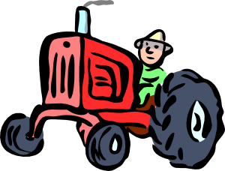
  - What is the error? ___ (Half the smallest unit)

  - Upper limit =

  - Lower Limit =

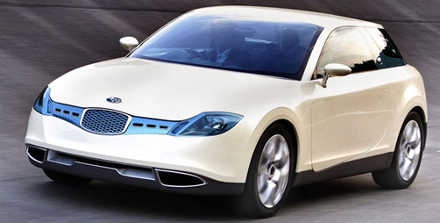
- A Subaru B5-TPH (Turbo/Parallel/Hybrid) hybrid car can go 1500 kilometres, accurate to 50 km, on a single tank of petrol. Within what limits of travel for this car?

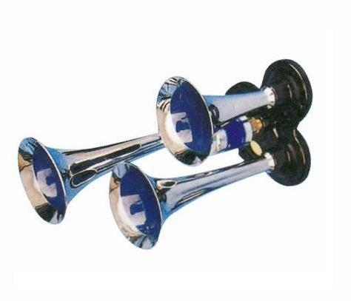

- A car horn has a measured output of 150 decibels, accurate to 10 decibels. Within what limits does this measurements lie?

